Galandriel Units and races

There are 6 main races of creatures in the world at this point in time (3/7/2014):

Dragons

Nature

Undead

Demons

Humanoids

Elementals

**Nature** – this set of races includes animals and plants like creatures. Also included are the good humanoid creatures such as the decorns and airavians.

Current list of nature creatures

Wisp

Dryad

Satyr

Decorn *

Winged Decorn *

Trunker

Beaked Snulfin

Freata

High Decorn *

Great Decorn *

Chlorsye

Treant

Airavians

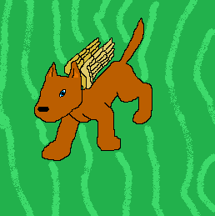Decorn- The basic of the decorn lines. The decorn is a winged dog at this point in its development

Winged decorn- these are the more wild and animal like of the decorn lines. They do not like in cities or very large groups. They are however still sentient beings

High decorn – These comprise the majority of the city dwelling decorns. These decorns help keep the peace and order across the world.

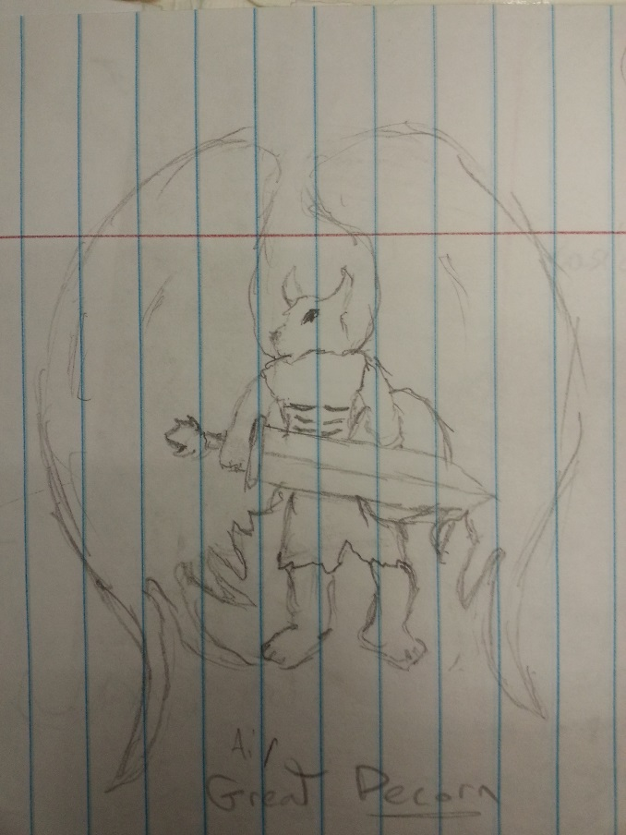Great Decorn – these decorn also reside in the major cities of the world and are the great rulers. During the high age of the Decorn they are the main force for good. This age is the golden age of the decorn. The great decorns are elevated high decorns.

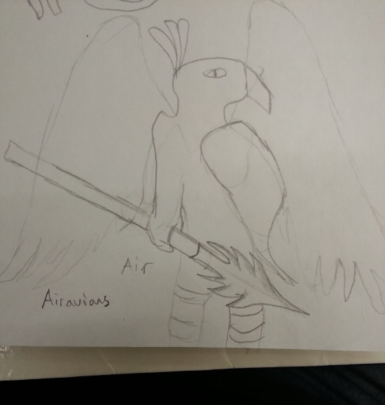Airavians – These birdlike humanoids are nomadic and live in different tribes. After the fall of the decorn they become the largest group of the good humanoids but do not rise to the same amount of power and strength that the decorns did during the high age.